Time-series Stock Price Predictive Analytics

# Introduction

The stock market began in 1792 at Wall Street, New York with a few stockbrokers on the street (Posner, 2020). This platform has allowed investors to buy and sell shares of a public company or better well known as stocks. Other investments include bonds and commodities such as gold and oil. The main benefits from an investor’s perspective are to stay ahead of inflation with compound interest and personal financial growth. With pros come cons and the main disadvantages are competition and risk (Amadeo, 2020).

The S&P 500 is based on the top 500 companies in America and is considered a benchmark for annual stock market returns. Many investors know that the long-term investment into the S&P 500 has an average return on investment of 10% and as a benchmark investor’s goal is to outperform it. With technology growing, algorithm trading has found a place in the stock market. Using data from the market and time-series predictive analytics can a model be built to outperform the S&P500 for individual investors.

# Literature Review

Recently the stock market has seen a major crash in 2020 due to the COVID-19 pandemic. This has caused the volume of stock trading to go up and lead the market to be flooded with new cash resulting in a quick recovery. With emerging technology, the stock market is adapting towards algorithm trading. “Algorithmic trading is the process of buying or selling a security basing on some pre-described set of rules tested on historical data” (Turner, 2019). This technology was used to help Tesla buy 1.5 billion dollars’ worth of bitcoin at a good average price. The popularity of algorithm trading grew massively over the years to 85% of market volume in 2012 (Turner, 2019). This method of trading has proven to be beneficial and eliminates poor trading ideas (Turner, 2019).

# Dataset

The dataset used in this research is sourced from Yahoo Finance. It includes over 7500 instances for each individual stock and has 7 attributes. The data attributes outline the ticker symbol, date, volume, and various prices.

Attribute Information:

* Symbol – Ticker Symbol
* Date: Year-Month-Day
* Close – Closing Price
* High – Day High Price
* Low – Day Low Price
* Open – Opening Price
* Volume – Volume of Stock

Each of the attributes will be used to create a time series stacked LSTM model to predict the future trends of the stock market.

# Approach

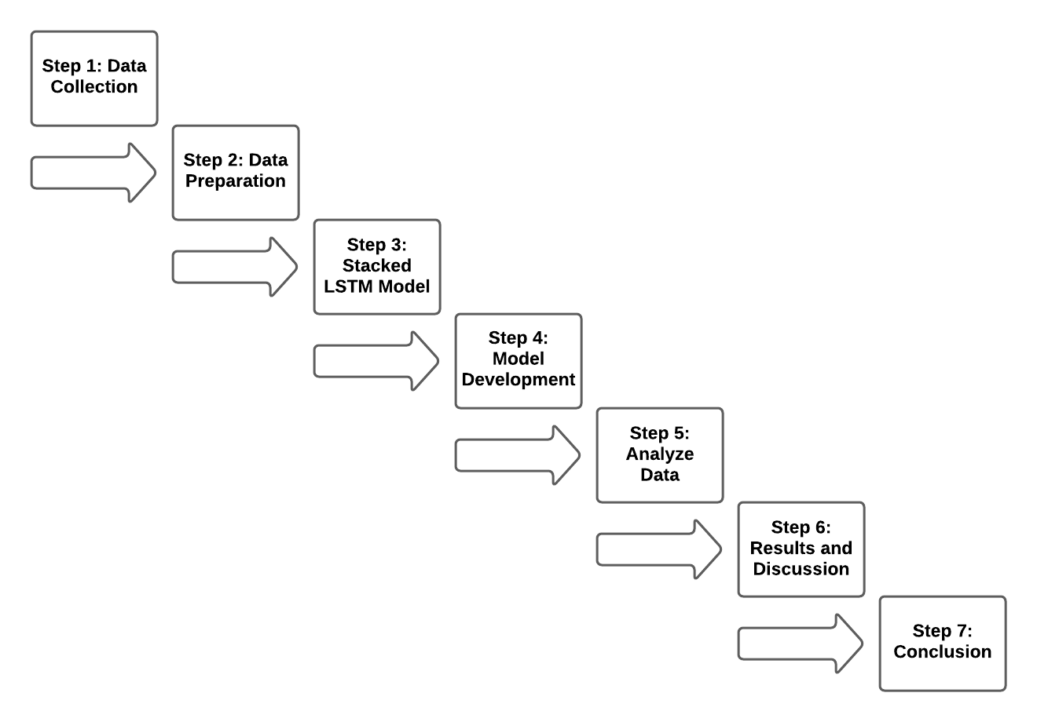

## Step 1: Data Collection

* Import data from Yahoo Finance.
* Understand the attributes.
* Visualize the correlation to find connections and attribute importance.
* Create a boxplot to show the distribution of each attribute.

## Step 2: Data Preparation

* Check for missing values and outliers.
* Divide dataset into training and test sets.

## Step 3: Stacked LSTM Model

* Using time-series predictive analytics to create a stacked LSTM Model.

## Step 4: Model Development

* Predict the test data and the future stock performance.

## Step 5: Analyze Data

* Compare the model’s performance with actual data.

## Step 6: Results and Discussion

* Display results.
* Analyze the research findings.
* Answer the project question.

## Step 7: Conclusion

* Summarize the research and project question.

# Citation

Posner, J. (2020). Explained The Stock Market [Video]. Netflix.

Amadeo, K. (2020). Pros and Cons of Investing in Stocks. Retrieved 15 February 2021, from https://www.thebalance.com/stock-investing-for-the-individual-investor-3306182

Turner, C. (2019). The Future Of Algorithmic Trading. Retrieved 15 February 2021, from https://www.experfy.com/blog/fintech/the-future-of-algorithmic-trading/